May 18th, 2022
Kenneth R. Gottfried
1067 S. Hover St.
Ste E-178 Longmont, CO, 80501

Mr. Josh Stein
Attorney General’s Office
9001 Mail Service Center
Raleigh, NC 27699-9001

Dear Mr. Stein:

I hope you are doing well in these crazy days.

I am in a quandary and have been put in a position where I absolutely request your advice.

As you know, I wrote you a letter on December 1st 2017. (https://www.childabusivejudges.com/josh-stein.html )
Since this letter you ordered your attorney: Hugh Harris to do his best to defuse the situation with making the least waves possible and protect the child abusive judges who abused my under-aged daughters.
I explained this within your council and AG's office
This included covering up of child abusers and domestic violence ordered by judges in your state. Specifically Judge Hal G. Harrison, Judge F. Warren Hughes and Judge Rebecca Eggers-Gryder.

Here is where my confusion comes in.
- I reported the deprivation of rights by Judge Hal Harrison and Judge F. Warren Hughes under the color of law to the North Carolina Judicial Standards Commission. I was told by Judge Bryant and the Judicial Standards Commission that they do not care about my constitutional rights or my children and the NCJSC protect judges no matter how much factual data a person provides.
- When I reported psychological and emotional child abuse to both Tom Hughes and Chad Slagle of the Watauga County DSS they both blatantly lied about what North Carolina considers child abuse and refused to do any type of actual investigation. They both claimed that emotional and psychological, abuse is not something that North Carolina investigates. Tom Hughes and Chad Slagle have proclaimed to be experts in the field of Psychological Child Abuse DSM-5 V995.51 and a shared persecutory delusion (psychological child abuse) and to my knowledge have never even spoken with my daughters. Tom Hughes even demanded that I contact Watauga County’s attorney: Andrea Capua with Disanti, Watson Capua (Watauga County’s Council). Coincidentally, Andrea Capua was my attorney approximately 2 years earlier on the same case.
- I tried to file criminal child abuse charges with Watauga County’s Sheriff Len Hagaman and his department. Sheriff Len Hagaman ordered his entire staff to only let him handle this case and anything I try and file. Sheriff Hagaman committed malfeasance by not even writing up a single report. I was told to go to the Watauga County Attorney Tony disanti. Tony disanti refused to reply to any of my correspondence and had another attorney send a cryptic email. When I responded to her email the offices of Disanti Watson and Capua refused to respond. Coincidentally, Tony disanti was the head attorney with the law firm approximately 2 years earlier on the same case with Andrea Capua.
- I contacted Seth Banks, Watauga County’s district attorney whose staff acknowledged he protects child abusers when they are judges and refused to respond to any of my attempts to contact him.
- The Boone police department acknowledged that they have no jurisdiction to go after child abusers and cut all communications.
- I reported the conflict of interests with Disanti Watson and Capua to the NC State Bar Association. I was told by the State bar there was no conflict what-so-ever. Really? The State bar wrote “you can represent someone and then represent an organization against that client less than 3 years later with no conflict of interests on the exact same case. And you can advise that client to lie, protect child abusers and commit color of law violations at will. https://www.childabusivejudges.com/nc-bar-association.html
- I contacted the North Carolina State Bureau of Investigation. After speaking with Chris Laws (an SBI investigator) personally, he advised me that he was an expert in psychological and emotional child abuse and my case needed no further investigation because he knows all about a shared persecutory delusion and did not even need to contact my children. The case was closed.
- Lambert Guinn US attorney western NC (How many child abusers are there holding positions in the Justice system?). Spoke to him personally. He actually put the hickory FBI on my case where I received 1 phone call. They left a message to call back. Tried calling them back for weeks. They refused to answer their phone or return the calls.
- The Federal Bureau of Investigation does its best to lie and cover up anything that could make them look bad. The best I can explain about this department is that they are completely impotent. Read about them here: https://www.childabusivejudges.com/fbi.html
- Christopher Wray Director of the FBI. https://www.childabusivejudges.com/fbi.html Letter sent December 30th, 2021. No Response.

This inspired me to write two books.
- Victim https://read.amazon.com/kp/embed?asin=B087MZ9G2H&preview=newtab&linkCode=kpe&ref_=cm_sw_r_kb_dp_K9GEEMJAEE7ZJY1VRJQK
- Killing Judges https://read.amazon.com/kp/embed?asin=B0887TMB65&preview=newtab&linkCode=kpe&ref_=cm_sw_r_kb_dp_PFHY7AQFZFC2XW6RT9X5

At this point there is a statute in North Carolina that MANDATES you or anyone to report suspected child abuse. N.C.G.S. § 7B-301. To my knowledge neither you nor your attorney or anyone listed above reported suspected child abuse. Please let me know where to report you and your attorney Hugh Harris as well as the people listed above of this crime?
The sad part, even if you did report it, there were Chad Slagle and Tom Hughes at the DSS ready to lie and deny any investigation about the child abuse

Even with a hard copy in my hand of 3 confirmed ethics violations from the North Carolina Board of Professional Counselors on Lyric Fitzgibbons who directly psychologically abused my daughters, Judge F. Warren Hughes allowed her to testify in my case as an EXPERT witness. Judge Hughes did this with only a 1-day notice and overruled my attorneys’ objections. Judge Hughes knew full well that in North Carolina any expert witness requires a minimum of a 5-day notice for due process.

You see, one can’t win a game that has been fixed. Like when Rebecca Egger’s (Now a family court judge) with law firm Eggers, Eggers, Eggers and Eggers bribed judge Hal G. Harrison to do their bidding. Yes, the exact bribes are acknowledged and documented by the North Carolina Disclosure report. An ironic point: They are documented by the North Carolina State Board of Elections and Ethics Enforcement Examples: https://www.childabusivejudges.com/judge-hal-harrison.html

Based on my experience the workings of your department, the NC justice system, and it’s oversite committees can without any doubt be considered a child trafficking ring.

You and your institutions routinely abuse children and parents to the point of life long emotional issues and committing suicide.
The APA has pointed this out in their letter to the president of the United States in June 2018.
https://www.apa.org/advocacy/immigration/separating-families-letter.pdf
The context of the letter was based on empirical evidence with decades of psychological research.

That being said: Just in my case, Judge Hal G. Harrison, Judge F. Warren Hughes, Rebecca Eggers, Tamera Divinire, Christy Gottfried, Lyric Fitzgibbons, Tom Hughes and Chad Slagle psychologically abused my daughters to the point of harming (destroying) my relationship with my daughters and are guilty of domestic violence and child abuse. This is the exact definition for emotional domestic violence from the United States Department of Justice.

Having the North Carolina Judicial Standards Commission, the NC State Bar, Josh Stein, sheriff Len Hagaman, Boone Police Department, The North Carolina SBI and the FBI All take part is simply reprehensible.

Even Appalachian State Psychology Department Dr. Kurt Michaels, Rose Mary Webb and all those listed above REFUSED TO REPORT SUSPECTED CHILD ABUSE MANDATED BY N.C.G.S. § 7B-301. How in the world is this possible? More to the point, how is this legal?

So here comes my main question and the reason for this letter.
It is imperative your advice be considered because it is about child abuse, child trafficking, domestic violence, and murder. It will have implications that will mean the difference between life and death. It will have effects on families for generations.

I have a website: ChildAbusiveJudges.com
I have tried to point out the corruption and child abusers who have abused my daughters and stripped away my constitutional rights.

The website generates many views and I receive messages from other parents/grand-parents, family members and their fight against these child abusers and the organized tyrants who protect these child abusers (Child trafficking ring).

After my experience with you (Josh Stein), your office and the many organizations listed above, I am at a loss on what to say to the people that contact me. I have spoken to so many people that have witnessed their children abused directly in front of them and there is nothing they can do. Almost all were put into a position of having emotional domestic violence ordered by these tyrants and just in the last month I have personally spoken with two parents that called out Judge Hal G. Harrison and Rebecca Eggers Gryder by name as judges who are abusing or have abused their children and ordered emotional domestic violence.

Please note that these children who have been or are being psychologically abused are in imminent danger and/or may have been severely emotionally compromised from this judicial ordered abuse.

Please tell me what advice you would recommend I give these parents?
I wrote down some options for you to choose from.
Please remember: It would be ill-advised for me to recommend them to try any of the routes I have taken as the people who are in place are only there to protect child abusers.
I have been told by many parents that they have also gone the same routes only to witness their children further abused and retribution/retaliation by the justice system.
I could not in good conscience recommend any of the normal advised avenues.
Please understand many of these children are in a position of imminent danger.
Please take into consideration that I have exhausted what I believe are all the all routes to report this domestic violence, and child abuse only to fall on a system that protects child abusers and encourages domestic violence.

As a peaceful person, I would never recommend the use of these choices but will tell parents and families in these situations that you and your department are completely aware the circumstances and since the AG’s office refuses to do anything the AG’s office officially recommendation is this would be your only option.

- Do you recommend using a person’s 2nd amendment right to protect their family from an abusive tyrannical government, to come into your office, house or any event and exercise that right?
- Do you recommend using a person’s 2nd amendment right to protect family from an abusive tyrannical government, they come into judges Hal G Harrison’s office, house or any event and exercise that right by shoving him into a woodchipper feet first and taping this child abusers screams for other family court judges to hear?
- Do you recommend using a person’s 2nd amendment right to protect family from an abusive tyrannical government, they come into judges Rebecca Eggers-Gryder office, house or any event and exercise that right by setting her on fire directly in front of the courthouse?
- Do you recommend using a person’s 2nd amendment right to protect family from an abusive tyrannical government, come into Sheriff’s office, house or any event and exercise that right?
- Do you recommend using a person’s 2nd amendment right to protect family from an abusive tyrannical government, come into the NC Judicial Standards office, house or any event and exercise that right?
- Do you recommend using a person’s 2nd amendment right to protect family from an abusive tyrannical government, they come into Christopher Wray’s, office, house or any event and exercise that right?
- Do you recommend finding the children of any of these tyrants and kidnap their children and abuse them? After all, if these tyrants do not care about our children and family, the likelihood of them caring less about their own children is extremely high. Correct?
- Do you recommend using a person’s 2nd amendment right to blow up buildings like the Oklahoma bombing from an abusive tyrannical government?
- Do you recommend using a person’s 2nd amendment right to delete politicians who created and blatantly allow this kind of abusive tyrannical government?
- Would you recommend this last request?
- Do you recommend that the abused parents, family members, organize a well-armed militia and kill all involved in this child abuse and destruction of families all at once?
- Other options. Again, I am always open for other options that work. Please add any comments: ________________________________________________________________________________________________________________________________________________________________________________________________________________________
________________________________________________________________________________________________________________________________________________

Now, I realize the 2nd amendment right is a last resort for any United States citizen to use. As you have seen, I would never advise any of these routes and have personally exhausted what I believe to be every means possible. I have witnessed over and over again that the North Carolina and United States justice system is set up for self-preservation and not to protect our children or We the People’s Constitutional Rights.

An additional quandary, by using any 2nd amendment right on the child abusers, a person would be forced to exercise that right on any approaching, sheriff, deputies, police department, SBI or FBI agents that would be called to protect the child abuser and child trafficking ring so the flow of money could continue to be generated into the State of North Carolina.

Please include your recommendation of how you would handle these possibilities and remember:
You were informed about these judges abusing my daughters years ago through several ways of contact. Phone calls directly to your office and a certified letter. You chose to run interference, protecting these child abuser and profit from your actions. Now more children and parents are being traumatized and abused as a direct result of your actions even by the same judges.

Please note: I have not seen or heard from my daughters in almost 9 years. Psychological child abuse does not stop when they turn 18 or hit a certain age, so, I am not kidding in the least about this letter.

I eagerly await your recommend actions to tell these parents I have spoken to and continually speak with. Many of these parents are being abused and forced to watch their children abused right in front of their faces.

Here is hoping you have a wonderful day.
Thank you for your help and time in this matter, I eagerly await your response.
Please tell Anna, Leah, Adam, and Sam I send my love.

If I do not hear from you in a timely manner, (10 days), I will forward the message that Josh Stein and you’re the entire North Carolina’s Attorney Generals department will do nothing about this known child trafficking and Josh Stein encourages people to use their 2nd amendment constitutional right to protect their family and children.

Sincerely

Kenneth Gottfried
A father to 3 abused daughters

cc: media outlets

Reference material:
- DSM-5 V995.51 Psychological child abuse
- Separating family’s letter, American Psychological Association: https://www.apa.org/advocacy/immigration/separating-families-letter.pdf
- Suicides from separating families (Partial list): https://www.childabusivejudges.com/suicides.html
- Exact Definition of Emotional Domestic Violence from the United States Department of Justice: “Damaging ones relationship with his/her children”
- APA press release Oct 2014 Psychological abuse as harmful as sexual and psychological abuse. https://www.apa.org/news/press/releases/2014/10/psychological-abuse
- The Contribution of Psychological Maltreatment to Child and Adolescent Mental Health and Risk Outcomes www.apa.org/pubs/journals/releases/tra-a0037766.pdf
- CDC distribution of child abuse:

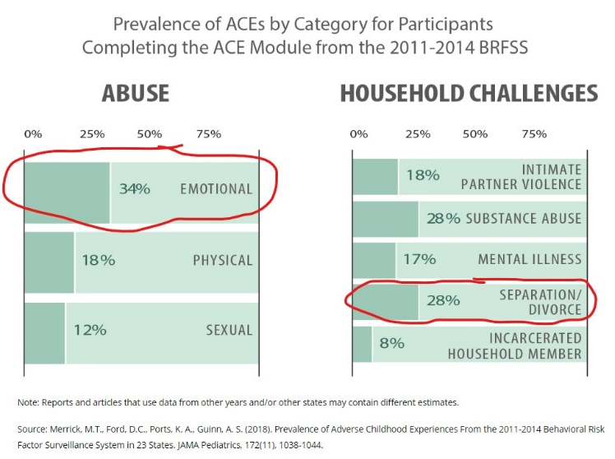

This brings up an extremely important question. If emotional/psychological child abuse is 34% and sexual plus Physical child abuse is 30% combined, why does North Carolina show that only 1-2% of children are emotionally abused, and most of the maltreatment is neglect? https://cwoutcomes.acf.hhs.gov/cwodatasite/pdf/north%20carolina.html
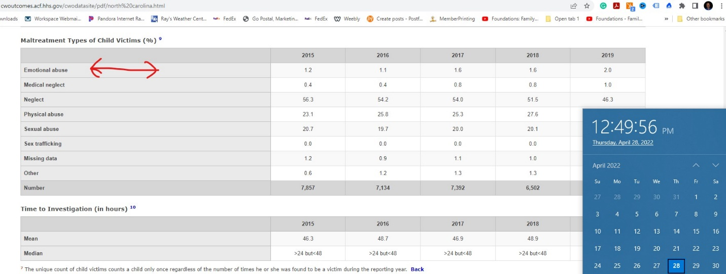

Just in my case of: FRAUD, Fraud Upon the Court False Claims, Illegal Filings and
moral turpitude

Feb 5th 2015: Judge Warren Hughes refuses to allow me to see my children and denies me due process. For the next 6 months he allows continuance after continuance abusing and traumatizing my children by erasing me out of their lives. This is nothing short of ordering Domestic Violence and Emotional child abuse.
August 8th, 2015: Judge Hughes once again refuses me due process by allowing my oldest daughter to testify. There she will utter words no parent should hear. “My father never loved me”.
Judge Hughes again does not give me any time with my children. No reason behind his decision. Personally, I am emotionally starting to break. Having not had time with my daughters in almost 2 years, I can see from afar that there is something severely wrong with my daughters. My daughters’ abuse and trauma show in their eyes.
August 19, 2015: I filed emotional child abuse charges with the Watauga Department of Social Services. They do not investigate emotional abuse, even when it is spelled out in the complaint. They refuse to investigate.
Dec 2, 2015: Judge Hughes orders my children into private chambers and witnessed the emotional child abuse 1st hand. My children are crying, shaking and are inconsolable. They show all symptoms of severe emotional child abuse. Stating things like “I wish my father was dead.”
Judge Hughes refused to report child abuse mandated by the state: NC state statute G.S. 7B-301(a) (Yes, I did see this first-hand when I witnessed one of my children come out of the judge’s chambers). Judge Hughes refused to report emotional child abuse and continued to order domestic violence and child abuse. (I was in absolute disbelief and snapped after having witnessed my daughters being so traumatized walking out of the judge’s chambers. At the time, I was so full of confusion and rage that I felt like I could have killed Judge Hughes on the spot for what he had ordered.)
Dec 3, 2015 Out front of the courthouse I demonstrated knowing Judge Hughes abused my children. https://www.hcpress.com/news/business-owner-in-child-custody-battle-protests-in-front-of-watauga-county-courthouse-in-boone.html
Dec 3, 2015: Judge Hughes recused himself, and Judge Hal G Harrison takes over. With only a 40-minute notice to appear in court, Judge Hal Harrison refused me due process (NC requires a 5-day notice for preparing for court) and issues an illegal gag order for me protesting across the street after realizing how psychologically abused and traumatized my daughters were. What I did not realize was that it was an unlawful gag order. When asked in court for my daughters to be seen by a specialist in psychology, Judge Harrison refused. (At this time Judge Harrison was aware of the trauma my daughters were going through, and was fully aware of the child abuse. He refused to report child abuse as mandated by the state: NC state statute G.S. 7B-301(a).)
This is where the systemic child trafficking really begins to show itself. Watauga DSS refused to investigate child abuse, Judge Hughes abused my daughters and here comes Judge Hal Harrison to continue and escalate the orders of child and judicial abuse.
In my mind, the questions persist daily. How can I protect my daughters? How can I get them help? How can I reach out? What do I do when the government officials are the ones abusing my children?
Feb 5th, 2016: Back in court. While I was the stand, I was given a signed order that I had never seen. I told the judge I that I had never seen this order. Later, Judge Hal Harrison stated in open court “I would like to get down to the bottom of this! “ and proceeded to order my previous attorney (Nancy Rivenbark) to the stand to testify against me, on the same day and in the next couple of hours.
To make this perfectly clear, Judge Hal G. Harrison ordered my previous attorney to the stand to testify against me. He ordered and colluded with Tamera DiVenere to file a subpoena to have my previous attorney testify against me on the same day within about 2 hours. (Turns out my previous attorney forged my name on the order in question while I was in Florida. 3-30-2015)
May 2016: I was ordered by judge Hughes and the accountant (Controller) to pay the mortgage on a piece of property mutually owned to prevent it from going into foreclosure. (This was the same accountant refusing to pay me the court ordered salary that I was ordered to recieve.)
May 17, 2016: Judge Hughes issues a restraining order forbidding me from entering my own business, evicting me from where I was living, and preventing me from going on any property I owned. All based on fraudulent findings of fact conspired with Tamera DiVenere.
May 19th, 2016: Judge Hal Harrison signs and issues a subpoena to me for May 20th, 2016. (Less than 24 hours)
May 20th, 2016: Without an attorney and without due process Judge Hal Harrison denied me a continuance. Judge Hal Harrison puts me in jail for 30 days over my daughters High School Graduation. While in jail, I lost a business I had been building for over 2 years, a location I was renting for another business, loss of $75,000 in business property, and the worst part was, missing my daughter’s high-school graduation
At this point, I kind of lost it mentally.
To understate the corruption in the family court system is to deny reality.
From the time in jail, watching my children abused in front of me, losing my businesses, having no place to live, zero income, restrained from all my properties, not being able to contact or help my children finally took its toll: I was diagnosed with all the symptoms of complex-PTSD.
My next court date was asked to be continued. I even had a letter from my therapist that I was ordered by him not to show up in court for 60 days.
July 20, 2016: Judge Hal Harrison issues an arrest warrant for me not being able to show up to court. Completely abandoning the Americans with Disabilities Act.
August 18, 2016: I was given an ultimatum and blackmailed by Judge Hal Harrison: either sign over 100% of everything I ever owned and worked for or go to jail indefinitely. Neither were good options, especially now dealing with the severity of Complex-PTSD.
On that day I was blackmailed by Judge Hal G. Harrison for over 5.5 million dollars.
Years later, I found out that he had received bribes by law firm Eggers, Eggers & Eggers while running his campaign.
My complaints to the North Carolina Judicial Standards Commission were met with, “We protect judges not the people’s rights.”
Tom Hughes and the Watauga DSS refusal to investigate and actively obstructed child abuse claims protecting child abusers.
Sheriff Len Hagaman blocked any reports of child abuse that I tried to file.
North Carolina Attorney General Josh Stein refused to actively help in any way.
And now, more and more people are calling me because their children and themselves are being abused by the same judges and others all across the United States and the world.

